**AN ENGINEERING MID-TERM PROJECT REPORT**

**On**

**“Car Game”**

**Submitted By**

**Anup Adhikari 200306**

**Bishal Bhadel 200314**

**Laxmi Raj Pant 200320**

**Nirmal Tamang 200321**

**Submitted to**

**The Department of IT and Computer Engineering**

**In Partial fulfillment of requirement for the degree of**

**Bachelor of Engineering** **in Information Technology**



**Cosmos College of Management & Technology**

**(Affiliated to** **Pokhara University**)

**Tutepani, Lalitpur, Nepal**

**Date of Submission: 2023-09-21**

**AN ENGINEERING MID-TERM PROJECT REPORT**

**On**

**“Car Game”**

**Submitted By**

**Anup Adhikari 200306**

**Bishal Bhadel 200314**

**Laxmi Raj Pant 200320**

**Nirmal Tamang 200321**

**Under the Supervision of**

**Kushal Ghimire**

**Submitted To**

**The Department of IT and Computer Engineering**

**In Partial fulfillment of requirement for the degree of**

**Bachelor of Engineering** **in Information Technology**



**Cosmos College of Management & Technology**

**(Affiliated to Pokhara University)**

**Tutepani, Lalitpur, Nepal**

**Date of Submission**: **2023-09-21**

# CERTIFICATE (On Letter Head)

The undersigned certify that they have read & recommended to the Department of Electronics & Communication / IT & Computer, a second-year project work entitled “Car Game” submitted by the following students in partial fulfillment of the requirements for the degree of Bachelor of Engineering.

Anup Adhikari 200306

Bishal Bhadel 200314

Laxmi Raj Pant 200320

Nirmal Tamang 200321

Kushal Ghimire

(Project Supervisor)

Department of ICT

Cosmos College of Management and Technology

Name of External Examiner

(External Examiner)

Designation

Name of Institute

_____________________________

Bibek Ropakheti

Head of the Department

Department of IT and Computer Engineering

Cosmos College of Management and Technology

# ACKNOWLEDGMENT

We express our sincere thanks to all IT department teachers for the help and advice given to us and we would also like to thank **Cosmos College** for providing all the resources and ideal environment for project developing process and encourage us for developing such kind of the project.

We would also like to share our gratitude to **Pokhara University** for providing opportunity to evaluate our programming skills through this project.

We would like to thank our class members who directly and indirectly helped us for guidance. We are also obliged to all the writers whose articles are used as references.

# ABSTRACT

In our first project our group would like to implement a car racing game. This game is being developed so that it can help children to stay home by playing game and avoiding of getting bored. We have tried to implement a car racing game based on 2D console. The main objective of this game is to survive by getting high scores with efficient speed with avoiding the obstacle on the track. The final score will be posted according to the number of obstacles we avoid.

Overall, our project will deliver 2D console-based car racing game that provides a fun and engaging experience for all types of players, while also offering a unique and innovative addition to the existing range of car racing games in the market.

# ABBREVIATION

2D 2 Dimensional

3D 3 Dimensional

IDE Integrated Development Environment

CPU Central Processing Unit

SDLC Software Development Life Cycle

SFML. Simple and Fast Multimedia Library

# LIST OF FIGURES

Figure 1 Waterfall Model 5

[Figure 2 Player Main Menu View 7](https://d.docs.live.net/930371c992a8971d/Documents/Project%20I%20Final%20Report.docx#_Toc146027022)

Table of Contents

CERTIFICATE (On Letter Head) I

ACKNOWLEDGMENT II

ABSTRACT III

ABBREVIATION IV

LIST OF FIGURES V

CHAPTER-1: INTRODUCTION 1

1.1 Background of the Project 1

1.2 Problem of Statement 1

1.3 Objectives 1

1.4 Limitations 2

CHAPTER-2: LITERATURE REVIEW 3

CHAPTER-3: METHODOLOGY 4

CHAPTER-4: PROBLEMS ENCOUNTERED 9

CHAPTER-5: FUTURE ENHANCEMENTS 10

CONCLUSION 11

REFERENCES 12

# CHAPTER-1: INTRODUCTION

### Background of the Project

The inspiration for this car racing game projects come from our shared interest in cars and gaming. As the group of students with a passion for game development we have always been fascinated by the speed and excitement of car racing, and we believe that a game that captures this feeling could be both fun and challenging on a console platform.

The goal of this project is to create a 2D console-based car racing game that is both challenging and entertaining, while also keeping the game mechanics and graphics simple. We will focus on creating a game with responsive and intuitive controls that make the gameplay feel smooth and enjoyable.

Although our game will have less graphics and design, we will still aim to make it visually appealing and immersive by adding appropriate sound effects. As a group we bring together skills in programming and game design to ensure a well-rounded development process.

### Problem of Statement

The problem statement for this 2D console-based car racing game are as follows:

* Existing car racing games are too complicated for casual gamers or those who want a simpler gameplay experience.
* There is need for games with uncomplicated controls and straightforward gameplay mechanics.
* Despites its simpler graphics and design, there is demand for visually appealing and engaging games.

### Objectives

Some important goals of car racing game are as follows column:

* To develop a 2D console-based car racing game that is easy to play but still provides a challenging and fun experience for players of all skill levels.
* Simple controls and straightforward gameplay mechanics.
* To create visually appealing and immersive gameplay, enhancing the overall player experience despite its simpler graphics and design.
* To create a game that can be played by a wide range of players from beginners to advanced gamers.
* To implement a dynamic game mechanic that gradually increases the car’s speed as gameplay progresses, adding excitement and challenges.
* To integrate background music to enhance the overall atmosphere and enjoyment of the game.
* To implement collision detection and response mechanism to end the game when the player’s car collides with the incoming traffic.
* To implement game-over condition based on the player’s remaining lives, ending the game when the player loses all their lives.

### Limitations

While our project demonstrates successful demonstration, it also has certain limitations:

* **Absence of Player data tracking**

The game lacks a player data tracking system, including score storage, due to the absence of a database. This means that player progress and high scores are not retained between game sessions.

* **Old-Fashioned Gameplay**

Our game draws inspiration from classic car racing games, which may not align with the expectations and preferences of modern gamers who are accustomed to more sophisticated graphics and gameplay features.

# CHAPTER-2: LITERATURE REVIEW

Car racing games are a popular genre in the gaming industry, with many variations ranging from arcade style games to more realistic simulations. Research shows that the appeal of car racing games is driven by the immersive experience they provide, the excitement of high-speed racing, and the competition among players.

While there are many successful 3D car racing games in the market, there is also a growing interest in 2D car racing games that provide a simpler and more accessible gameplay experience. 2D car racing games are often favored by casual gamers or those who prefer who simpler controls and mechanics.

A study conducted by Gualeni, and colleagues (2019) found that players of 2D racing games value the game’s accessibility and ease of play, as well as its visual and audio effects. They also found that players prefer games that provide a sense of progression and challenge, as well as social interaction among players.

In terms of game design, research suggests that 2D car racing games should focus on creating a visually appealing environment with a variety of tracks, vehicles, and powerups that keep the game interesting and challenging. Simplicity in game mechanics and controls is also key, as it allows players to focus on the excitement of the race.

Overall, the literature suggests that a 2D console-based car racing games can be successful if it provides a fun and engaging gameplay experience that is accessible to a wide range of players, while also incorporating unique and innovative features that set it apart from existing game in the market. (The Study Genius- Prashant)

# CHAPTER-3: METHODOLOGY

##### Introduction

Methodology refers to the systematic approach and techniques to navigate the journey from project initiation to successful completion. It encompasses the structured and methods utilized to guide the project from its inception to the attainment of its goals. This section will delve into the specific steps and procedures undertaken to develop and deliver the 2D car racing game, providing insights into project’s workflow and decision-making processes.

##### Software Development

**Waterfall Model Approach**

The waterfall model approach was selected for this project due to its ability to provide a structured framework for software development. This approach allows for revisions and adjustments after each stage is completed, ensuring a higher likelihood of project success.

The waterfall model one of the earliest SDLC models, divides the entire software development process into distinct and sequential phases. Each phase’s output serves as the input for the subsequential phase, following a linear and sequential progression. It is known for its simplicity and ease of comprehension.

The diagram below illustrates various phases of the Waterfall model:

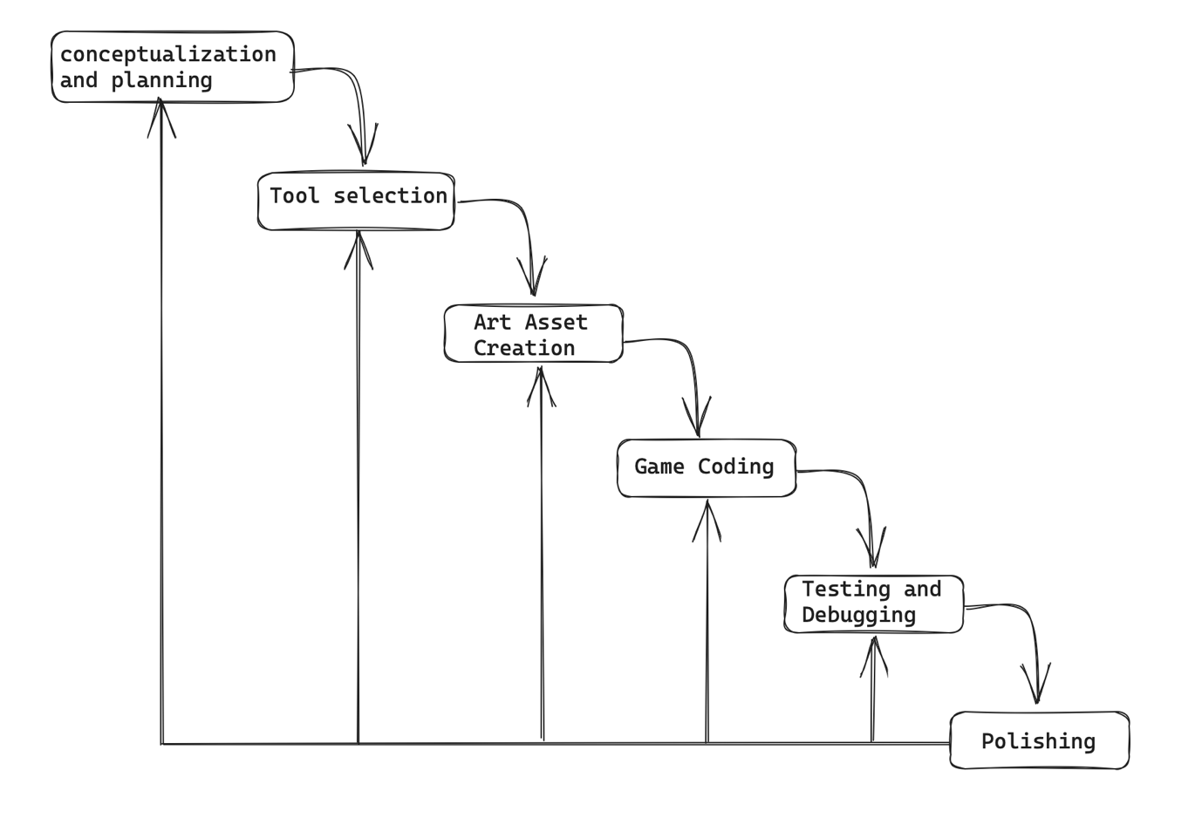

Figure Waterfall Model

The sequential phases in Waterfall model are:

1. **Conceptualization and Planning**
   * Initially, we conducted extensive research by exploring online resources, including websites and video tutorials, to gain insights into designing a 2D car racing game.
   * We gathered relevant content and ideas to effectively conceptualize and plan our project.
2. **Tool Selection:**
   * We carefully evaluated various development tools and platforms to choose the most suitable one for our project.
   * After thorough consideration, we opted for Visual Studio Code due to our prior familiarity with it.
3. **Art Asset Creation:**
   * The visual elements of our game, including background scenery, user car, and opponent cars (incoming traffic), were created as, sprites.
   * We harnessed the capabilities of the SFML (Simple and Fast Multimedia Library) to seamlessly integrate these art assets into our project.
   * This approach significantly enhanced the visual appeal and overall user experience.
4. **Game Coding**
   * During the coding phase, we leveraged a variety of resources, including GitHub, the official SFML library documentation, and instructional YouTube tutorials.
   * These resources provided invaluable guidance, code examples, and best practices, facilitating the development of our game.
5. **Testing and Debugging:**
   * Rigorous testing procedures were implemented to identify and rectify any potential bugs, glitches, or gameplay issues.
   * The debugging phase was essential to ensure the game’s stability and smooth functionality.
6. **Polishing**
   * In the final stages, we focused on adding additional elements to enhance the game’s overall quality.
   * Sound effects and music were integrated to provide a more immersive and polished gaming experience.

##### Requirement Analysis

In this section of requirement analysis, we are setting both the hardware and software requirements to the minimum level right now that are used worldwide.

Hardware Requirements:

* Memory: 4GB (minimum)
* CPU: Modern processor with at least 2 cores or higher
* Screen: 1280 x 800 minimum screen resolution
* keyboard: Normal
* Mouse: Normal

Tools and environment

Language: C++

IDE: Visual Studio Code

##### Working Principle

The working principle of our 2D car racing game is centered on providing players with an immersive and enjoyable gaming experience through simple yet engaging gameplay mechanics. The game operates within a sequential and iterative framework, which can be broken down into several key components:

* Initialization:
  + When the game starts, it initializes all necessary resources, including graphics, sound effects, and game variables.
  + The user is presented with the main menu window, displaying various options like start game option, instruction option etc.
  + This is the main menu with various options:

Figure 2 Player Main Menu View

* User Interaction:
* The player can control their car using keyboard input, allowing for movements in all four directions.
* The interaction is processed in real-time, enabling smooth and responsive control over the user’s car.
* Scoring:
* A scoring system keeps track of the player’s performance. Points are gained for avoiding obstacles and progressing further in the game.
* The player’s score is displayed on the screen, allowing them to track their progress.
* Collision Detection:
* The game constantly checks for collisions between the player’s car and opponent cars.
* If a collision occurs, the player loses a life.
* Lives and Game Over:
* The player starts with 3 lives and is displayed as hearts.
* When all lives are lost, the game is over, and the final score is displayed.
* Progressive Difficulty:
* As the game progresses, the opponent’s car speed increases gradually for every 100 points gained.
* This creates a challenging and dynamic gameplay experience.
* Game loop
* The game operates within a continuous loop, where user input, car movements, scoring, and collision detection are updated and checked in each iteration.
* This loop ensures that the game responds to player actions in real-time.

# CHAPTER-4: PROBLEMS ENCOUNTERED

###### Introduction

In this chapter we are introducing the various problems and challenges that we faced from the beginning of the project to its completion. We faced various problems beginning from setting up environment for coding to various errors and challenges in our code.

###### Conceptualization and planning phase:

* Initially we had some general idea about how our game is going to be, but we had no idea of how to start and how to initiate our project.
* Starting from choosing the programming language to appropriate IDE.

###### Art asset creation phase:

* At first, we were thinking of creating ASCII art for our background as well as user and opponent car.
* Then, we heard about sprites and things became little easier because sprites can be easily manipulated to move, change color and various things.

###### Tools and Technology phase:

* With our initial knowledge and experience of programming we had no idea to get started with our project like creating a window, showing various option, playing with sound etc.
* During our research, we found out that there are various libraries we can use that can help with our previous doubts and problem.
* And we ended up choosing SFML library for our project that can help with our various needs.
* After choosing SFML library setting up the library on our local machine was another challenge for us and took us days to finally setup.

###### Game Coding phase:

* With our initial experience in coding where our programs were short and simple but with this project coding was becoming tough.
* During initial coding phase, we had placed all the code in same file, and it makes our code messy and difficult to read and organize.
* Then, we create different header file for different sections which helps us to organize and maintain our code properly.

###### Testing and Debugging phase:

* During this phase we had many challenges like:
* Moving the background constantly
* Managing the sound
* After doing various research on google, YouTube and GitHub, we finally became able to move the background smoothly.
* For managing the same sound in various program files, we finally became able manage the sound after learning about the “extern” keyword.

# CHAPTER-5: FUTURE ENHANCEMENTS

Introduction

In this chapter, we explore the exciting possibilities for enhancing our project in the future. While our current game represents a significant achievement, we recognize that there is always room for improvements and innovations. We aim to take our project to the next level by addressing the following key areas:

* **Database Connectivity**

Our game currently lacks database connectivity, which limits our ability to track player progress, maintain high scores, and offer personalized gaming experiences. By integrating database support, we can provide players with a more immersive and competitive environment, enhancing their overall gaming experience.

* **Multiplayer Mode**

Presently, our game offers a single-player mode. To broaden its appeal and foster social interaction among players, we envision adding a multiplayer feature. This will enable friends and competitors from around the world to engage in thrilling races together, elevating the excitement and competitiveness of the game.

* **More cars and Tracks**

To enhance player choice and variety, we plan to introduce options to selecting different cars and tracks. This will allow players to customize their gaming experience to their preferences, adding depth and personalization to the gameplay.

* **Mobile Version**

Recognizing the widespread use of the mobile devices, we intend to develop a mobile version of our game. This strategic move will make our game accessible to a broader audience, enabling users from diverse backgrounds and regions to enjoy our creation on their smartphones and tablets.

# CONCLUSION

In conclusion, our journey in developing in developing this 2D car racing game has been a rewarding and enlightening experience. This project allowed us to apply our knowledge and skills in programming, game development, and problem-solving to create an engaging and enjoyable game. We achieved several significant milestones and learned valuable lessons along the way.

From conceptualization and planning to coding and debugging, we navigated through various phases of development. We successfully implemented core gameplay features, such as car movement, collision detection, and scoring, which form the foundation of our game’s mechanics.

One of the highlights of our project is the integration of the SFML library, which greatly facilitated the incorporation of visual elements, including background sprites and car images. This decision not only enhanced the game’s visual appeal but also contributed to its immersive quality.

Moreover, our dedication to continuous improvement led us to address initial code organization issues and improve our coding practices. The transition from a single code file to organized header files enhanced the readability and maintainability of our codebase.

In closing, we are proud of what we have accomplished, and we are excited about the potential for future enhancements and the opportunity to share our game with a wider audience. This project represents the beginning of our journey in game development and look forward to exploring new horizon int this dynamic field.

# REFERENCES

https://thestudygenius.com/car-game-in-c/

https://www.sfml-dev.org

chat.openai.com

<https://github.com/nguyenhopquang/CarRacing.git>

https://github.com/SonarSystems/SFML-Box2D-Tutorials/tree/master